MINISTRY OF EDUCATION AND SCIENCE OF UKRAINE

NATIONAL TECHNICAL UNIVERSITY

“KHARKOV POLYTECHNICAL INSTITUTE”

LABORATORY WORK № 5

Working with Structures and Files

Created by student of 1.КН.201.8г

Chukwu Irele omike

Teacher

LUTENKO I.V

KHARKIV 2018

Laboratory Training 5

Working with Structures and Files

1.1 3D-points

Write a program that calculates distance between two 3D-points. Use printf() function for output.

1.2 Average

Write a program that reads floating point type values from a text file and calculates arithmetic mean of these values.

1.3 Individual Assignment

You should write a program that provides file input and output and implements an assignment of previous laboratory training. You should implement following steps:

definition of a constant (n) which determines column count of two-dimensional array

opening file for reading (file should be prepared using some text editor)

reading integer values until the end of file and storing them in the linked list

creation of two-dimensional array in free store; row count should be calculated based on amount of integer values read from file and count of columns

filling of two-dimensional array row by row; missing elements of the last row should be set to zeroes;

removing elements of linked list from free store

implementation of previous assignment

storing results in a new file

removing both arrays using delete operators.

Task 1 : The code

#include "pch.h"

#include <iostream>

#include <math.h>

using namespace std;

struct point

{

int x, y, z;

};

int sqr(int a)

{

return a \* a;

}

double distance(point p1, point p2)

{

return sqrt(sqr(p2.x - p1.x) + sqr(p2.y - p1.y) + sqr(p2.z - p1.z));

}

void main()

{

point p1;

point p2;

cin >> p1.x >> p1.y >> p1.z;

cin >> p2.x >> p2.y >> p2.z;

cout << "distance = " << distance(p1, p2) << "\n";

system("PAUSE");

}

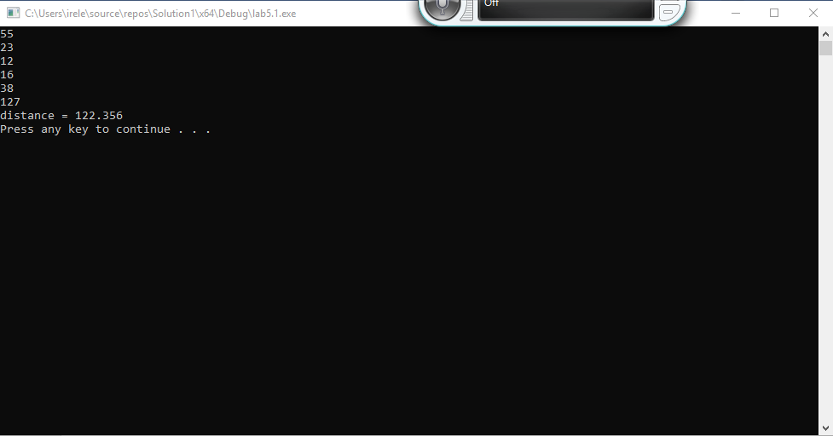

Task 2: the code

#include "pch.h"

#include <iostream>

#include <fstream>

using namespace std;

int main()

{

double sum = 0, d, counter = 0;

ifstream in("file.txt");

while (in >> d)

{

counter++;

sum += d;

}

printf("%f", sum / counter);

system("pause");

}

Execution:

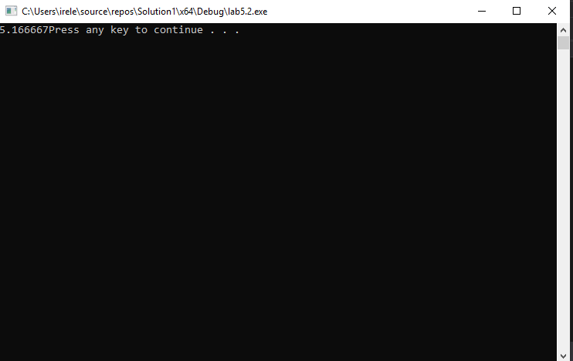

Task three: the code :

#include "pch.h"

#include<iostream>

#include <fstream>

#include <iomanip>

using namespace std;

struct Link

{

double data;

Link \*next;

};

double \*\*readFromFile(const char \*fileName, int &count, const unsigned int n)

{

Link \*first = 0;

Link \*last = 0;

Link \*link;

ifstream in(fileName);

double d;

count = 0;

while (in >> d)

{

count++;

link = new Link;

link->data = d;

link->next = 0;

if (last == 0)

{

first = last = link;

}

else

{

last->next = link;

}

last = link;

}

double \*\*arr = new double\*[n];

for (int i = 0; i < n; i++)

{

arr[i] = new double[n];

}

link = first;

for (int i = 0; i < n; i++)

{

for (int j = 0; j < n; j++)

{

if (link == NULL)

{

arr[i][j] = 0;

}

else

{

arr[i][j] = link->data;

link = link->next;

}

}

}

while (first)

{

link = first;

first = first->next;

delete link;

}

return arr;

}

void outToFile(const char \*filename, double \*\*arr, const unsigned int n)

{

ofstream out(filename);

for (int i = 0; i < n; i++)

{

for (int j = 0; j < n; j++)

{

out << setw(4) << arr[i][j] << " ";

}

out << endl;

}

out.close();

}

void outToFile(const char \*filename, double \*arr, const unsigned int n)

{

ofstream out(filename);

for (int i = 0; i < n; i++)

{

out << setw(4) << arr[i];

out << endl;

}

out.close();

}

double \*\*calc(double \*\*arr, const unsigned int n)

{

for (int i = 0; i < n; i++)

{

for (int j = 0; j < n; j++)

{

if (arr[i][j] > 0)

arr[i][j] = log10(arr[i][j]);

else

{

arr[i][j] = arr[i][j];

}

}

}

return arr;

}

double \*calc2(double \*\*arr, const unsigned int n)

{

double \*ptrarray = new double[n];

int k = 0;

for (int j = 0; j < n; j++)

{

int sum = 0;

for (int i = 0; i < n; i++)

{

if (arr[i][j] < 0)

sum += arr[i][j];

}

ptrarray[k] = sum;

k++;

}

return ptrarray;

}

void main()

{

const unsigned int n = 4;

int count = 0;

double \*\*arr = readFromFile("read.txt", count, n);

for (int i = 0; i < n; i++)

{

for (int j = 0; j < n; j++)

cout << setw(4) << arr[i][j];

}

double \*\*arr1 = calc(arr, n);

for (int i = 0; i < n; i++)

{

for (int j = 0; j < n; j++)

{

cout << arr1[i][j] << " ";

}

cout << endl;

}

outToFile("output1.txt", arr1, n);

double \*arr2 = calc2(arr, n);

outToFile("output2.txt", arr2, n);

delete[] arr;

system("pause");

}

Execution :

